Monday: Solve the following system of equations using the ALGEBRAIC METHOD. SHOW ALL WORK BELOW!!

1. y = 4x – 8 2. y = x – 2 3. 3x – 6y = 30 4. y = 3
y = 2x + 10 2x + 2y = 4 6x + y = 34 2x + y = _ 15

Tuesday: Representing Relationships – read each problem, answer each question.
Days, d | Bulbs, b
1 | 950
2 | 1,900
3 | 2,850
4 | 3,800

1. PRODUCTION A manufacturer produces 950 light bulbs per day. #1.

a. Write an equation to find the number of bulbs b the manufacturer makes in any number
of days d.

b. Use the equation to determine how many bulbs the manufacturer will make in 25 days.

2. WATER The workers at a plant drink 38 gallons of water per day. #2.
Days, d | Gallons, g
1 | 38
2 | 76
3 | 114
4 | 152

a. Write an equation to find the number of gallons g the workers drink in any number of days d.

b. Use the equation to determine how many gallons of water the workers will drink in 30 days.

3. ALLOWANCE Chet gets $12 per week as allowance. #3.

a. Write an equation to find the amount of allowance a Chet receives in any number of weeks w.

b. Make a table to find the amount of allowance Chet receives in 5, 6, 7, or 8 weeks.
Then graph the ordered pairs.
Weeks, w | Allowance, a

Wednesday: Relations – follow each set of directions below.
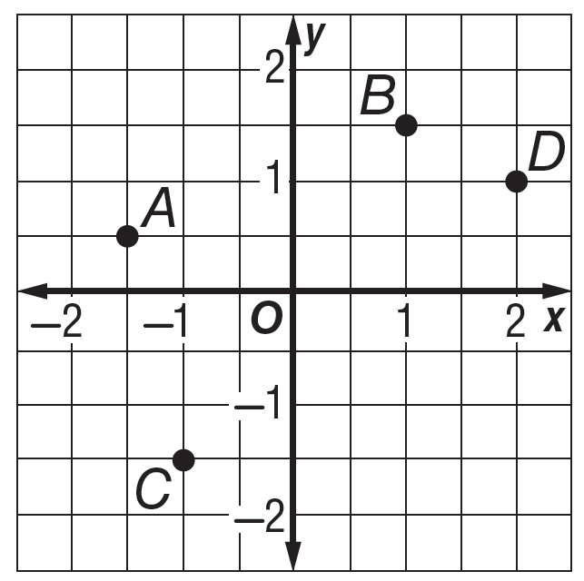
Name the ordered pair for each point.

1. A ( , ) 2. B ( , ) 3. C ( , ) 4. D ( , )

Graph each ordered pair on a coordinate plane.

5. $\left(1, \frac{1}{2}\right)$ 6. (1, − 2) 7. $\left(-\frac{1}{2}, 2\right)$ 8. $\left(2, -\frac{1}{2}\right)$

9. TELEVISION Alton pays $48 per month for satellite television service.
x | y

a. Make a table of ordered pairs in which the x-coordinate represents the number of months and the y-coordinate represents the total cost for 1, 2, 3, or 4 months.

Thursday:

1. Write an equation in slope intercept form given these two points (9,0) and (-2,2)

2. Write an equation to represent this scenario: Ms. Stelfox is inviting 200 guests to her wedding in January. There is a one time rental fee for the church that is $250.00. Each plate of food costs $85.00 per guest. Write an equation in slope-intercept form.

3. Use your equation to find out the TOTAL cost to having 200 people attend the wedding.

4. BE GOOD FOR THE SUBSTITUTES AND FINISH ALL HOMEWORK TO BE TURNED IN MONDAY!!!!

