Monday: Solve each equation. Check your work.

1. $0.4t = 0.72$ 2. $\frac{13}{7}n=-\frac{13}{14}$ 3. $-15 = 2t – 11$ 4. $6 + \frac{n}{5} = -4$ 5. $30 = -5d – 5$

6$. \frac{k - 3}{4} = 10$ Translate each sentence into an equation.
7. Three more than eight times a number is equal to 19. _______________________________

8. Twelve less than seven times a number is 16. ____________________________________

Tuesday: Solve each equation. Check your work.

1. $13 = 4x -11$ 2. $10 = \frac{z}{2} + 7$ 3. $-\frac{1}{3}y$ $- 6 = -1$ 4. $5 + 3w = 20$ 5. $\frac{z + 5}{7}$ $= -3$

Translate each sentence into an equation, then solve the equation. Check your work.

6. Four more than twice a number is –10. 7. Nine less than five times a number is equal to –30.

8. Kristina bought a canvas and 8 tubes of paint for $24.95. If the canvas cost $6.95, how much did each tube of paint cost?

9. The world’s two highest dams are both in Tajikistan. The Rogun dam is 35 meters taller than the Nurek dam.
Together they are 635 meters tall. Find the height of the Nurek dam.

Wednesday: Translate each sentence into an equation.

1. Four more than twice a number is 8. 2. Five less than twice a number is 7.

Translate each sentence into an equation & then solve the equation.

3. Nine less than six times a number is –15. 4. Eight more than the quotient of a number and 5 is 3.

5. Find the value of x in the triangle at the right. 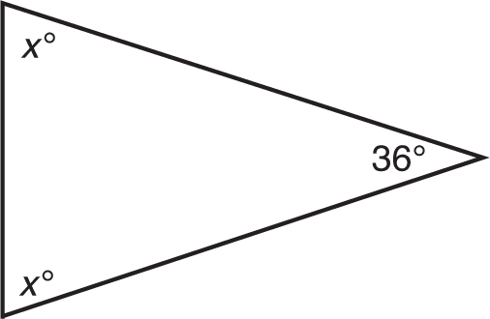

Thursday: Solve each equation. Check your solution.

1. 9m + 14 = 2m 2. 13x = 32 + 5x 3. t – 27 = 4t 4. 12 – 5h = h + 6

Write an equation & then solve your equation.

5. For an annual membership fee of $500, Mr. Bailey can join a country club that would allow him to play a round of golf for $35. Without the
membership, the country club charges $55 for each round of golf. How many rounds of golf would Mr. Bailey have to play for the cost to be the
same with and without a membership?

