**Monday: For Exercises 1 & 2, determine whether each linear function is a direct variation. If so, state the constant of variation.**

**1.**

|  |  |  |  |  |
| --- | --- | --- | --- | --- |
| **Price, *x*** | $5 | $10 | $15 | $20 |
| **Tax, *y*** | $0.41 | $0.82 | $1.23 | $1.64 |

|  |  |  |  |  |
| --- | --- | --- | --- | --- |
| **Hours, *x*** | 11 | 12 | 13 | 14 |
| **Distance, *y* (miles)** | 154 | 167 | 180 | 193 |

**2.**

**State the slope and the *y*-intercept for the graph of each equation. (#5 and #6 you need to get Y alone first!!)**

**5.** *y* – 2*x* = –1 **6.** *y* + 4*x* = 2 **7.** *y* = – $\frac{3}{2}$*x –* 3

**Graph each equation using the slope and the *y*-intercept.**

**8.** *y* = 3*x* – 3 **9.** *y* = –*x* + 1 **10.** *y* = $\frac{1}{2}$*x* – 2

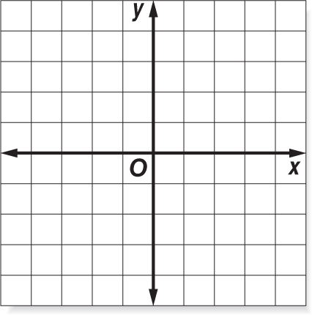





**Tuesday: State the *x*- and *y*-intercepts of each function. Please SHOW ALL work on a separate sheet of paper!!!**

**1.** –6*x* + 8*y* = 24 **2. $\frac{3}{4}x$** – 6*y* = 18 **3.** − $\frac{1}{4}x - \frac{1}{3}y$ = 12 **4.** *x* + *y* = 1

**State the *x*- and *y*-intercepts of each function. Then graph the function.**

**5. −** 4*x* + 2*y* = −8



**6. FARMING** Mr. Jeans raises cows and chickens on his farm. Altogether, his   
 cows and chickens have 140 legs. This can be represented by the function

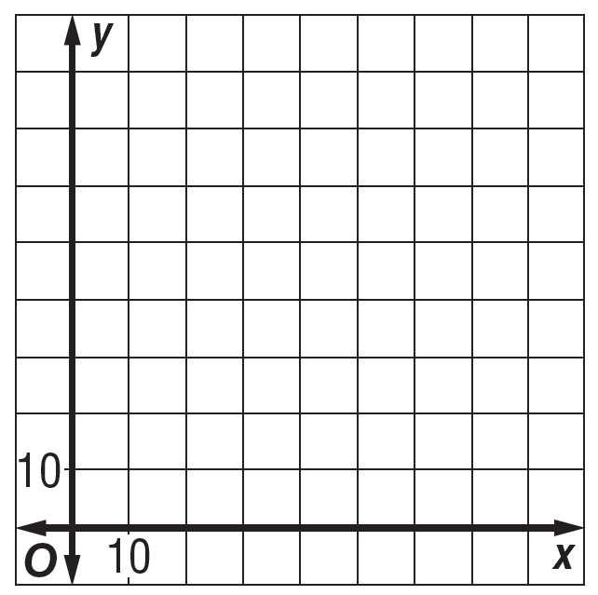

4*x* + *y* = 140. Graph the function. Then interpret the *x*- and *y*-intercepts.

**7. MONEY** Monty has a total of $290 in ten dollar and five dollar bills. This can be represented by the function

10*x* + 5*y* = 290. Interpret the *x*- and *y*-intercepts.

**Wednesday: SLOPE Review! Please use all of your knowledge about SLOPE (use notes if needed).**

1. Find the -intercept & the -intercept of the line below, then graph the equation.

a.  b.  c. 

x-intercept: ________ x-intercept: ________ x-intercept: __________

y-intercept: ________ y-intercept: ________ y-intercept: __________

2. Write the formula for finding the slope, : ________________________  
3. Find the slope, , of the line passing through the given two points. a.  b. 

**Thursday: Review more slope. Use notes if needed.**

1. Write the equation for slope-intercept form. _________________________

2. Write the following equations in slope-intercept form. State the slope and y-intercept. Then, graph the equation.

a.   b.  